**HW 3 R Code and Output**

**Problem 1**

**R Code**:

#Problem 1

n = 10000;

x= numeric(n);

f= numeric(n);

g= numeric(n);

x= rnorm(n);

g= dnorm(x);

for (i in 1:n) {

y= runif(1, 0, 1);

if (y<= 0.3)

{

f[i] = dbeta(x[i], 5, 2);

}

else

{

f[i] = dbeta(x[i], 2, 8);

}

}

expected.value <- sum(x*f/g)/sum(f/g)

#Computing the probability that the random variable is in the interval (0.35,0.55)

for (i in 1:n) {

temp <- runif(1, 0, 1);

if (temp <= 0.3) {

f[i] = rbeta(1, 5, 2);

} else {

f[i] = rbeta(1, 2, 8);

}

}

prob <- sum(f >= 0.35 & f <= 0.55)/n

**Results:**

> expected.value

[1] 0.3637159

> prob

[1] 0.1205

>

**Problem 3**

**R Code:**

#Problem 3

x=c(2.3656491, 2.4952035, 1.0837817, 0.7586751, 0.8780483, 1.2765341, 1.4598699,

0.1801679, -1.0093589, 1.4870201, -0.1193149, 0.2578262)

n = 100000

set.seed(123)

mu= numeric(n)

tau= numeric(n)

p=numeric(n)

mu[1] = rbeta(1, 2, 2)

tau[1] = rlnorm(1, 1, 10)

p[1] = 1/(sqrt(tau[1]*2*pi)^length(x))*exp(-sum((x-mu[1])^2)/(2*tau[1]))*dbeta(mu[1], 2, 2)*dlnorm(tau[1], 1, 10);

for (i in 1:n) {

mu_star = rbeta(1, 2, 2)

tau_star = rlnorm(1, 1, 10);

p_star = 1/(sqrt(tau_star*2*pi)^length(x))*exp(-sum((x-mu_star)^2)/(2*tau_star))*dbeta(mu_star, 2, 2)*dlnorm(tau_star, 1, 10)

theta = min(p_star/p[i], 1)

U = runif(1)

if(U < theta) {

mu[i+1] = mu_star

tau[i+1] = tau_star

p[i+1] = p_star

}

else {

mu[i+1] = mu[i]

tau[i+1] = tau[i]

p[i+1] = p[i]

}

}

#posterior prob of mu>=0.5

sum(mu >= 0.5)/n

hist(mu[1000:n+1])

plot(mu[1000:n+1], type='l', main="Trace plot for mu", xlab='Simulation number')

hist(tau[1000:n+1])

plot(tau[1000:n+1],type='l', main="Trace plot for tau", xlab='Simulation number')

plot(mu[1000:n+1], tau[1000:n+1], type='l', main='Trace plot for mu and tau')

acf(mu)

acf(tau)

**Result:**

[1] 0.82797

**Problem 3 Graphics:**

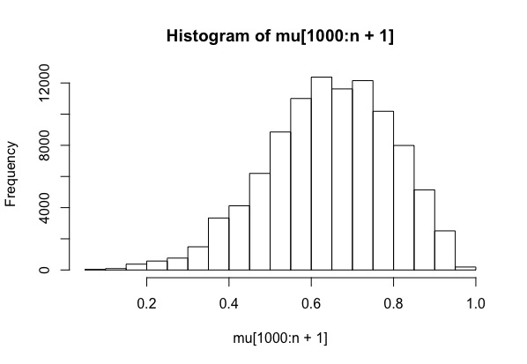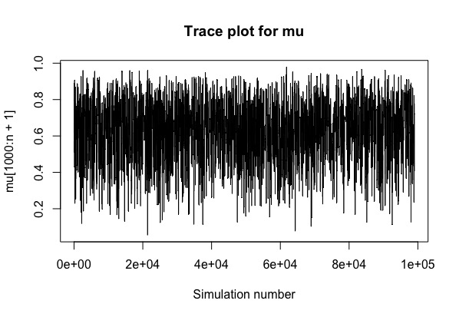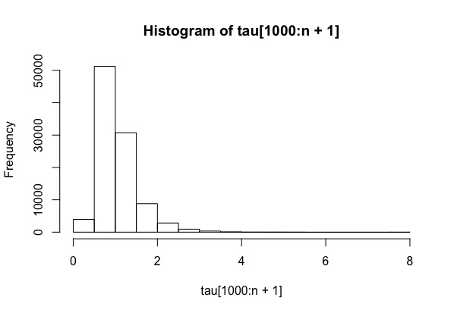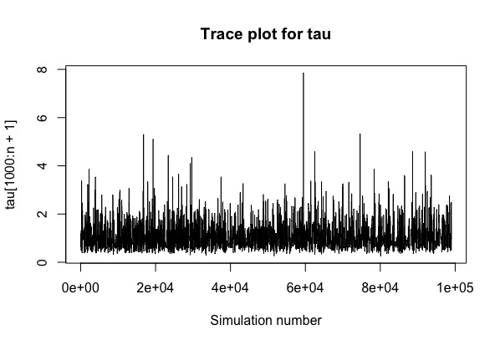

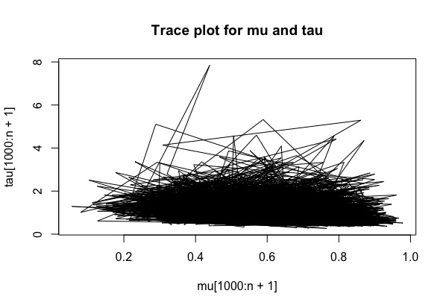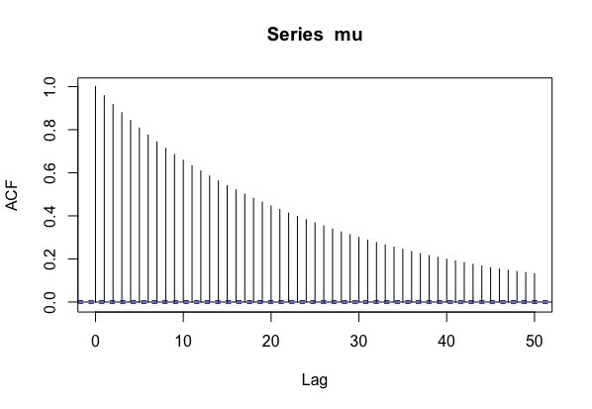

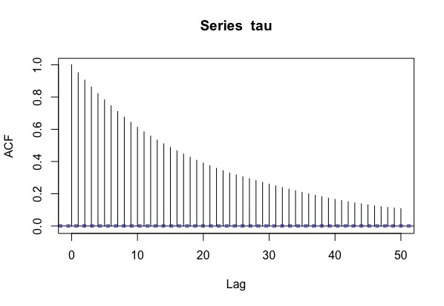

**Problem 4**

**Part a**

**R Code:**

#part a

glucose = read.table("glucose.dat", header = FALSE);

data=as.matrix(glucose)

data=as.numeric(data)

hist(data,breaks=seq(50,200,5),freq=FALSE,main="Problem 4 Part a")

lines(density(data))

**Result/Graphic:**

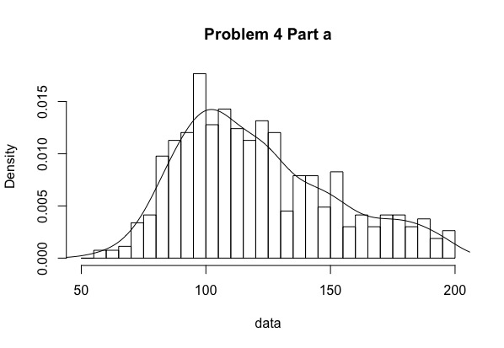

**Part c**

**R Code:**

#part c

y=data

set.seed(0)

n=length(y)

iter=10000

a=1

b=1

mu0=120

tao0.sq=200

sigma0.sq=1000

nu0=10

x=matrix(0,iter, n)

p=numeric(iter)

theta1=numeric(iter)

theta2=numeric(iter)

sigma1.sq=numeric(iter)

sigma2.sq=numeric(iter)

p[1]=rbeta(1, a, b)

x[1,]=rbinom(n,1,p[1])

theta1[1]=rnorm(1,mu0,sqrt(tao0.sq))

theta2[1]=rnorm(1,mu0,sqrt(tao0.sq))

sigma1.sq[1]=1/rgamma(1, nu0/2, nu0*sigma0.sq/2)

sigma2.sq[1]=1/rgamma(1, nu0/2, nu0*sigma0.sq/2)

for (i in 2:iter)

{

for (j in 1:n)

{

y1=dnorm(y[j], theta1[i-1], sqrt(sigma1.sq[i-1]))

y2=dnorm(y[j], theta2[i-1], sqrt(sigma2.sq[i-1]))

x[i,j]=rbinom(1,1,(p[i-1]*y1)/(p[i-1]*y1+(1-p[i-1])*y2))

}

c=sum(x[i,])

p[i]=rbeta(1,a+c,b+n-c)

y_1.bar=mean(y[x[i,]==1])

mu_n=(mu0/tao0.sq+c*y_1.bar/sigma1.sq[i-1])/(1/tao0.sq+c/sigma1.sq[i-1])

tao2_n=1/(1/tao0.sq+c/sigma1.sq[i-1])

theta1[i]=rnorm(1, mu_n, sqrt(tao2_n))

nu_n=nu0+c

s2_n=sum((y[x[i,] == 1]-theta1[i])^2)/c

sigma2_n=(nu0*sigma0.sq+c*s2_n)/nu_n

sigma1.sq[i]=1/rgamma(1,nu_n/2,nu_n*sigma2_n/2)

y_2.bar=mean(y[x[i,] == 0])

mu_n=(mu0/tao0.sq+(n-c)*y_2.bar/sigma2.sq[i-1])/(1/tao0.sq+(n-c)/sigma2.sq[i-1])

tao2_n=1/(1/tao0.sq+(n-c)/sigma2.sq[i-1])

theta2[i]=rnorm(1, mu_n, sqrt(tao2_n))

nu_n=nu0+(n-c)

s2_n=sum((y[x[i,] == 0]-theta2[i])^2)/(n-c)

sigma2_n=(nu0*sigma0.sq+(n-c)*s2_n)/nu_n

sigma2.sq[i]=1/rgamma(1,nu_n/2,nu_n*sigma2_n/2)

}

theta_1s=rep(0,iter)

theta_2s=rep(0,iter)

for (i in 1:iter)

{

theta_1s[i]=min(theta1[i], theta2[i])

theta_2s[i]=max(theta1[i], theta2[i])

}

acf(theta_1s,main="Problem 4 Part c, theta1 ")

acf(theta_2s,main="Problem 4 Part c, theta2 ")

effectiveSize(theta_1s)

effectiveSize(theta_2s)

**Results:**

> effectiveSize(theta_1s)

var1

418.4169

> effectiveSize(theta_2s)

var1

230.2658

>

**Graphics:**

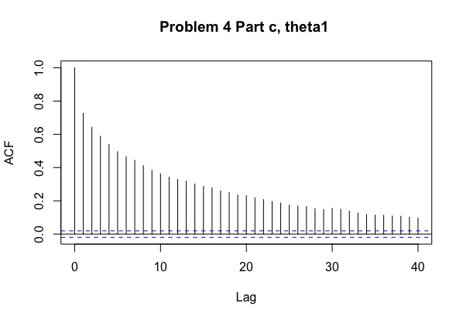

#part d

x_1=rbinom(length(p), 1, p)

y_1=numeric(iter)

for (i in 1:iter)

{

if (x_1[i] == 1)

{

y_1[i]=rnorm(1, theta1[i], sqrt(sigma1.sq[i]))

}

else

{

y_1[i]=rnorm(1, theta2[i], sqrt(sigma2.sq[i]))

}

}

hist(y_1,breaks=seq(0,300,5),freq=FALSE,main="Problem 4 Part d")

lines(density(y))

**Graphic:**

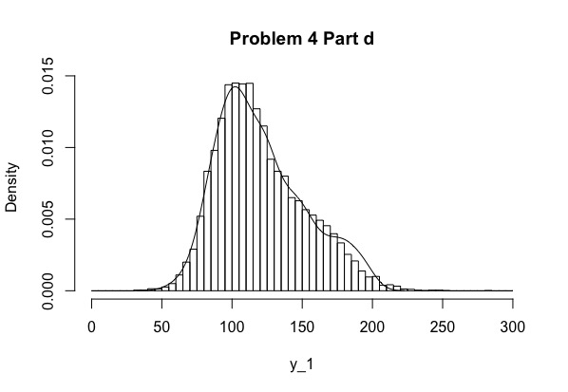

**Problem 5**

y=c(0,1,3,5)

n=c(5, 5, 5,5 )

x=c(-0.86,-0.30,-0.05,0.73)

#part 1 functions

part1post=function(alpha,beta,y,x,n){

prior=dnorm(alpha,0,10)

like=1

for(i in 1:4){

like=like*(inv.logit(alpha+beta*x[i]))^y[i]*(1-inv.logit(alpha+beta*x[i]))^(n[i]-y[i])

}

post=prior*like

return(post)

}

part1iter=function(alpha,beta=10,y,x,n,alphasd){

U=runif(1,0,1)

star=rnorm(1,alpha,alphasd)

p=min(part1post(star,beta,y,x,n)/part1post(alpha,beta,y,x,n),1)

if(U <= p)

{alpha=star}

else {alpha=alpha}

return(alpha)

}

#part 2 functions

part2post=function(alpha,beta,y,x,n){

prior=dnorm(alpha,0,10)*dnorm(beta,0,10)

like=1

for(i in 1:4){

like=like*(inv.logit(alpha+beta*x[i]))^y[i]*(1-inv.logit(alpha+beta*x[i]))^(n[i]-y[i])

}

post=prior*like

return(post)

}

part2iter=function(param,y,x,n,sd_param){

star1=rnorm(1,param[1],sd_param[1])

star2=rnorm(1,param[2],sd_param[2])

p1=min(part2post(star1,param[2],y,x,n)/part2post(param[1],param[2],y,x,n),1)

U=runif(1,0,1)

if(U <= p1)

{param[1]=star1}

else {param[1]=param[1]}

p2=min(part2post(param[1],star2,y,x,n)/part2post(param[1],param[2],y,x,n),1)

U=runif(1,0,1)

if(U <= p2)

{param[2]=star2}

else {param[2]=param[2]}

return(param)

}

#part 3 functions

part3post=function(param){

prior=dnorm(param[1],0,10)*dnorm(param[2],0,10)

like=1

for(i in 1:4){

like=like*(((inv.logit(param[1]+param[2]*x[i]))^y[i])*((1-inv.logit(param[1]+param[2]*x[i]))^(n[i]-y[i])))

}

post=prior*like

return(post)

}

part3iter=function(param,y,x,n,cov_mat=diag(1,2,2)){

star=mvrnorm(1,param,cov_mat)

U=runif(1,0,1)

p=min(part3post(star)/part3post(param),1)

if(U <= p)

{param=star}

else {param=param}

return(param)

}

#part 4 functions

part4iter=function(param,y,x,n,cov,delta){

normal_mean=param+delta*(theta_hat-param)/as.numeric(dist(rbind(param,theta_hat),method = "euclidean"))

star=mvrnorm(1,normal_mean,cov)

U=runif(1,0,1)

p=min((part3post(star)/part3post(param)),1)

if(U <= p)

{param=star}

else {param=param}

return(param)

}

alphasd=1

sd_param=c(1,2)

cov=diag(1,2,2)

delta=1

N=10000

post3n=function(param){

return(-part3post(param))

}

theta_hat=optim(c(1,1),post3n)$par

mc_1=numeric(N)

mc_2=array(NA,dim = c(2,N))

mc_3=array(NA,dim = c(2,N))

mc_4=array(NA,dim = c(2,N))

mc_1[1]=0

mc_2[,1]=c(1,10)

mc_3[,1]=c(1,10)

mc_4[,1]=c(1,10)

for (iter in 2:N){

alpha1=part1iter(mc_1[iter-1],beta=10,y,x,n,alphasd)

mc_1[iter]=alpha1

param2=part2iter(mc_2[,iter-1],y,x,n,sd_param)

mc_2[,iter]=param2

param3=part3iter(mc_3[,iter-1],y,x,n,cov_mat=diag(1,2,2))

mc_3[,iter]=param3

param4=part4iter(mc_4[,iter-1],y,x,n,cov,delta)

mc_4[,iter]=param4

}

hist(mc_1, main='histogram-alpha, part a')

hist(mc_2[1,], main='histogram-alpha, part b')

hist(mc_2[2,], main='histogram-beta, part b')

plot(mc_1, type='l')

plot(mc_2[1,], type='l')

plot(mc_2[2,], type='l')

plot(mc_3[1,], type='l')

plot(mc_3[2,], type='l')

plot(mc_4[1,], type='l')

plot(mc_4[2,], type='l')

acf(mc_1)

acf(mc_2[1,])

acf(mc_2[2,])

acf(mc_3[1,])

acf(mc_3[2,])

acf(mc_4[1,])

acf(mc_4[2,])

**Results & Graphics:**

